

|  |
| --- |
| **Design Brief** |

**Project Title:** NBA Data Analysis

**EQ**: Does a brutal loss usher to a continuous losing streak in future games and if so, how do these early losses affect future matchups?

**Clients:** Sean Cornish, Shauna Tsai

**Designer(s):** Ashkon Bashkar, Brandon Hill

**Problem Statement:**

An evident issue that underlies within numerous NBA teams is constant losing streaks. NBA teams operate on their quality and performance within games, yet unfamiliar teams are often overlooked due to a brutal loss. Based on 2015 to 2016 NBA standings on “Basketball Reference”, there are many unfamiliar teams that possess a bigger amount of losses than wins. This simply due to the fact that well-known teams, such as “Cavaliers”, can easily mutilate weaker teams (e.g., Boston Celtics) since they have a higher expectancy to win. Currently, the NBA conducts a system in which teams are regularly matched up in brackets. Officials assume that the league consists of favorable matchups, but they ignore the fact of competitive balance. Naturally, teams competing with the same remarks is considered fair play, but in the NBA, officials often matchup proficient teams with wobbly teams. Individuals can insist that randomizing matchups improve the aspect of fairness and in gameplay, but statistics show that teams with substantial players often known as “Super Teams” annihilate opponents without a fair fight (“Curry is Unfair”, 2016). According to Wall Street Journal, Paolo Uggetti proclaims that the “NBA Super team is becoming unfair”. He points out that Golden State Warriors draft player after player, in search for another “MVP”. With an alternative route to championships, non-proficient teams are left at a disadvantage; having no chance to advance in tournaments. If the NBA continues to regulate unfair matchups, it is true that this impact is continuing to elevate negativity within games.

Cited Sources:

1. <https://www.wsj.com/articles/the-nba-superteam-is-becoming-super-unfair-1467761695>
2. <http://www.basketball-reference.com/>

[http://www.trackalytics.com/the-most-liked-nba-teams-on-facebook/page/1/](http://www.basketball-reference.com/)

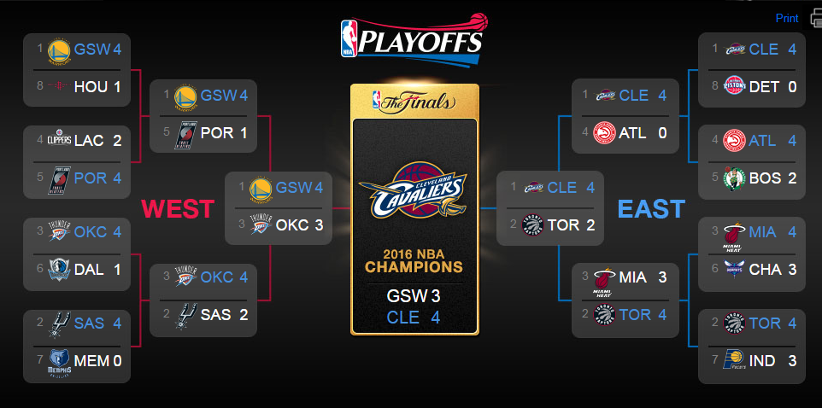

**Design / Concept Statement Instructions:**

Taking the statistics provided from “Basketball Reference” the graph will be a line graph that portrays the losing streak and the winning streak. Each team will be represented by their wins and losses. Using each specific team as a category, dots will represent their wins and losses. Red dots and lines will represent the losses and blue dots and lines will represent the wins for the graph. After plotting the data, we will look for patterns within the wins and losses. The streak will only be recognized if, after three losses, the team continues to lose.

**Constraints Instructions:**

Time will be a limiting factor in the duration of this project, as the time limit is one week. Another is that the question proposed must have an unsure-fit way of correlation. The data must explain the proposed question in a manner that may accurately provide a conclusion to the matter.